Міністерство освіти і науки України
Національний технічний університет України
«Київський політехнічний інститут»
Факультет інформатики та обчислювальної техніки
Кафедра обчислювальної техніки

ЛАБОРАТОРНА РОБОТА № 6

З дисципліни «Інженерія програмного забезпечення»

На тему « ШАБЛОНИ ПОВЕДІНКИ. ШАБЛОНИ STRATEGY, CHAIN OF RESPONSIBILITY, VISITOR»

ВИКОНАВ:
студент 2 курсу ФІОТ
групи ІО-41
Смішний Дмитро
Залікова - 4126
Варіант – 6

ПЕРЕВІРИВ:
Старший викладач
к.т.н., с.н.с.
Антонюк А.І.

Київ – 2015
ЗАВДАННЯ

Варіант 6.

Визначити специфікації класів для елементу ігрового поля (комірки) та самого простору. Забезпечити слабку зв'язаність елементів. Реалізувати децентралізований механізм сумісної зміни стану елементів.

ПРОГРАМНИЙ КОД
/**
* Class which formed game elements
* @author Smishniy Dmitriy
*
*/
public class ClientElement {
/**
* @param args
*/
private int posX;
private int posY;
private String name;

/**
*
* @param posX set x-position of element on field
* @param posY set y-position of element on field
* @param name set name of element
*/
public ClientElement(int posX, int posY, String name){
this.posX=posX;
this.posY=posY;
this.name=name;
}

/**
*
* @return Get position of element on the field
*/

public int getPosX(){
return this.posX;
}

/**
*
* @return Get position of element on the field
*/
public int getPosY(){
return this.posY;
}

/**
*
* @return Get name of element
*/
public String getName(){
return this.name;
}

}
/**
* Class, which implements interface Handler and send information about game element
* @author Smishniy Dmitriy
*
*/
public class ConcreteHandler1 implements Handler{
/**
* @param args
*/
public String message;
ClientElement[] clientelements;
PlayField playfield;

/**
*
* @param clientelements - set array of game elements
* @param playfield - set play field
*/
public ConcreteHandler1(ClientElement[] clientelements, PlayField playfield){
this.clientelements=clientelements;
this.playfield = playfield;
}

/**
* @return message about existence game element in the play field
*/
public void HandlerRequest(ClientElement el){
if (el.getPosX()<=playfield.getWidth() && el.getPosX()>=0 &&
el.getPosY()<=playfield.getHeight() && el.getPosY()>=0){
message = getPositiveMessage(el);
} else {
message = getNegativeMessage(el);
}
}
/**
*
* @param el game element
* @return message confirm existence of game element
*/
public String getPositiveMessage(ClientElement el){
return "Your element " +el.getName()+" in field.";
}

/**
*
* @param el game element
* @return message don`t confirm existence
*/
public String getNegativeMessage(ClientElement el){
return "Your elemnt "+el.getName()+" doesn`t in field.";
}

}
/**
* Class, which implements interface Handler, take message from ConcereteHandler1 and
* send info about possible way directions.
* @author Smishniy Dmitriy
*
*/
public class ConcreteHandler2 implements Handler{
/**
* @param args
*/
private String endMessage;
ConcreteHandler1 concretehandler1;
public int i=0;

/**
*
* @param concretehandler1 - set handler, that give info
*/
public ConcreteHandler2 (ConcreteHandler1 concretehandler1){
this.concretehandler1=concretehandler1;
};
/**
* Suggest about existence of possible ways
* @param el - game element
*/
@Override
public void HandlerRequest(ClientElement el) {
// TODO Auto-generated method stub
if ((concretehandler1.message).equals(concretehandler1.getPositiveMessage(el))){
whichWayDirection(el);
} else {
endMessage=concretehandler1.getNegativeMessage(el);
}

}

/**
*
* @param el game element
* @param dir possible direction
* @return free possible ways
*/
public String getDirectionMove(ClientElement el, String dir){
return concretehandler1.getPositiveMessage(el)+" "+dir+" is free. ";
}

/**
* Choose direction for move
* @param el game element
*/
public void whichWayDirection(ClientElement el){
if (i==concretehandler1.clientelements.length-1){
endMessage=getDirectionMove(concretehandler1.clientelements[i],"Right direction");
return;
}
if ((el.getPosX()+1)!=concretehandler1.clientelements[i+1].getPosX()){
endMessage=getDirectionMove(el,"Right direction");
} else if ((el.getPosX()-1)!=concretehandler1.clientelements[i+1].getPosX()){
endMessage=getDirectionMove(el,"Left direction");
} else if ((el.getPosY()+1)!=concretehandler1.clientelements[i+1].getPosY()){
endMessage=getDirectionMove(el, "Up direction");
} else if ((concretehandler1.clientelements[i].getPosY()-1)!=concretehandler1.clientelements[i+1].getPosY()){
endMessage=getDirectionMove(el,"Down direction");
}
i++;
}

/**
*
* @return message about moving
*/
public String getEndMessage(){
return endMessage;
}
}
/**
* Class, which set strategy for moving and implements it`s move-algorithm
* @author Smishniy Dmitriy
*
*/
public class Context {

/**
* @param args
*/
private Strategy strategy;
/**
* Set strategy
* @param strategy - moving strategy
*/
public void setStrategy(Strategy strategy){
this.strategy = strategy;
}
/**
*
* @return strategy algorithm
*/
public String doAlgorithmInterace(){
return strategy.AlgorithmInterface();
}

}
/**
* Interface, which help to handle some info and send message about handling
* @author Smishniy Dmitriy
*
*/
public interface Handler {
public void HandlerRequest(ClientElement el);

}
/**
* Determines playfield, where game elements is stay.
* @author Smishniy Dmitriy
*
*
*
*/
public class PlayField {
private int width;
private int height;

public PlayField(int width, int height){
this.width=width;
this.height=height;
}

/**
* Getter
*/
public int getWidth(){
return width;
}
/**
*
* Getter
*/
public int getHeight(){
return height;
}

}
/**
* Interface for strategy
* @author Smishniy Dmitriy
*
*/
public interface Strategy {
public String AlgorithmInterface();
}
/**
* Class, which implement interface Strategy and move element down
* @author Smishniy Dmitriy
*
*/
public class StrategyMoveDown implements Strategy {

/* (non-Javadoc)
* @see com.lab111.labwork6.Strategy#AlgorithmInterace()
*/
@Override
public String AlgorithmInterface() {
// TODO Auto-generated method stub
return moveDown();
}

public String moveDown(){
return "Game element go down.";
}
}
/**
* Class, which implement interface Strategy and move element left
* @author Smishniy Dmitriy
*
*/
public class StrategyMoveLeft implements Strategy{

@Override
public String AlgorithmInterface() {
// TODO Auto-generated method stub
return moveLeft();
}
public String moveLeft(){
return "Game element go left.";
}
}
/**
* Class, which implement interface Strategy and move element right
* @author Smishniy Dmitriy
*
*/
public class StrategyMoveRight implements Strategy{

@Override
public String AlgorithmInterface() {
// TODO Auto-generated method stub
return moveRight();
}

public String moveRight(){
return "Game element go right.";
}
}
/**
* Class, which implement interface Strategy and move element up
* @author Smishniy Dmitriy
*
*/
public class StrategyMoveUp implements Strategy {

/* (non-Javadoc)
* @see com.lab111.labwork6.Strategy#AlgorithmInterace()
*/
@Override
public String AlgorithmInterface() {
// TODO Auto-generated method stub
return moveUp();
}

public String moveUp(){
return "Game element go up.";
}
}
/**
* Working class
* @author Smishniy Dmitriy
*
*/
public class DoClass {

/**
* @param args
*/
static ClientElement pyramid = new ClientElement (26,78,"pyramid");
static ClientElement sphere = new ClientElement (27,58,"sphere");
static ClientElement cube = new ClientElement (43,63,"cube");
static ClientElement[] clientelements = {pyramid,sphere,cube};
static PlayField playfield = new PlayField(100,100);
static ConcreteHandler1 concretehandler1 = new ConcreteHandler1 (clientelements, playfield);
static ConcreteHandler2 concretehandler2 = new ConcreteHandler2 (concretehandler1);
static Context context = new Context();

public static void main(String[] args) {
// TODO Auto-generated method stub
doMethod();
}
/**
* Choose strategy for moving
*/
public static void doMethod(){
for (ClientElement el: clientelements){
concretehandler1.HandlerRequest(el);
concretehandler2.HandlerRequest(el);
if (concretehandler2.getEndMessage().equals(concretehandler2.getDirectionMove(el,"Right direction"))){
outputMethod(new StrategyMoveRight());
} else if (concretehandler2.getEndMessage().equals(concretehandler2.getDirectionMove(el,"Left direction"))){
outputMethod(new StrategyMoveLeft());
} else if (concretehandler2.getEndMessage().equals(concretehandler2.getDirectionMove(el,"Up direction"))){
outputMethod(new StrategyMoveUp());
} else if (concretehandler2.getEndMessage().equals(concretehandler2.getDirectionMove(el,"Down direction"))){
outputMethod(new StrategyMoveDown());
} else if (concretehandler1.message.equals(concretehandler1.getNegativeMessage(el))){
System.out.println(concretehandler1.message);
}
}
}
/**
* Set strategy
* @param strategy strategy
*/
public static void outputMethod(Strategy strategy){
context.setStrategy(strategy);
System.out.println(concretehandler2.getEndMessage()+context.doAlgorithmInterace());
}

}

ДІАГРАМА КЛАСІВ
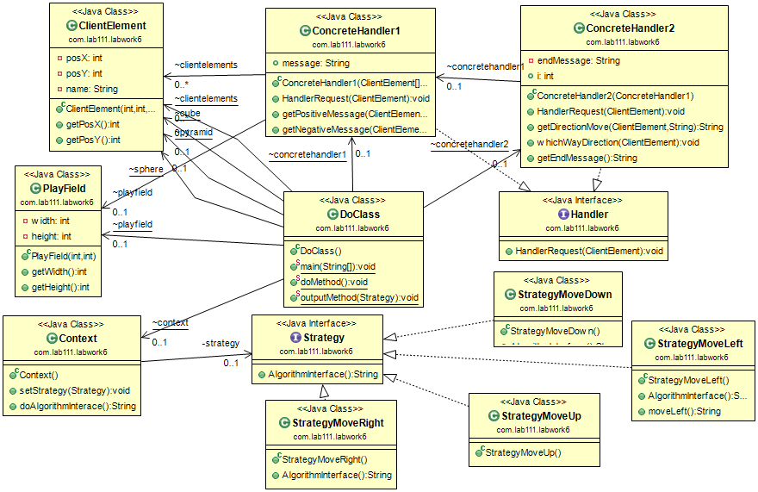

РЕЗУЛЬТАТИ ТЕСТУВАННЯ ПРОГРАМИ

Your element pyramid in field. Left direction is free. Game element go left.
Your element sphere in field. Right direction is free. Game element go right.
Your element cube in field. Right direction is free. Game element go right.

ВИСНОВКИ

Ознайомились із шаблонами поведінки Strategy, Chain of responsibility та Visitor.
Отримали навички із застосування шаблонів.
Розроблена відповідна тестова програма.
Результати успішної роботи тестової програми наведені вище підтверджують правильність обраних рішень.

